**Ideation Phase**

**Define the Problem Statement**

|  |  |
| --- | --- |
| Date | 26 October 2022 |
| Team ID | PNT2022TMID43116 |
| Project Name | SmartFarmer-IOT Enabled Smart Farming Application |
| Maximum Marks | 2 Marks |

**Customer Problem Statement:**

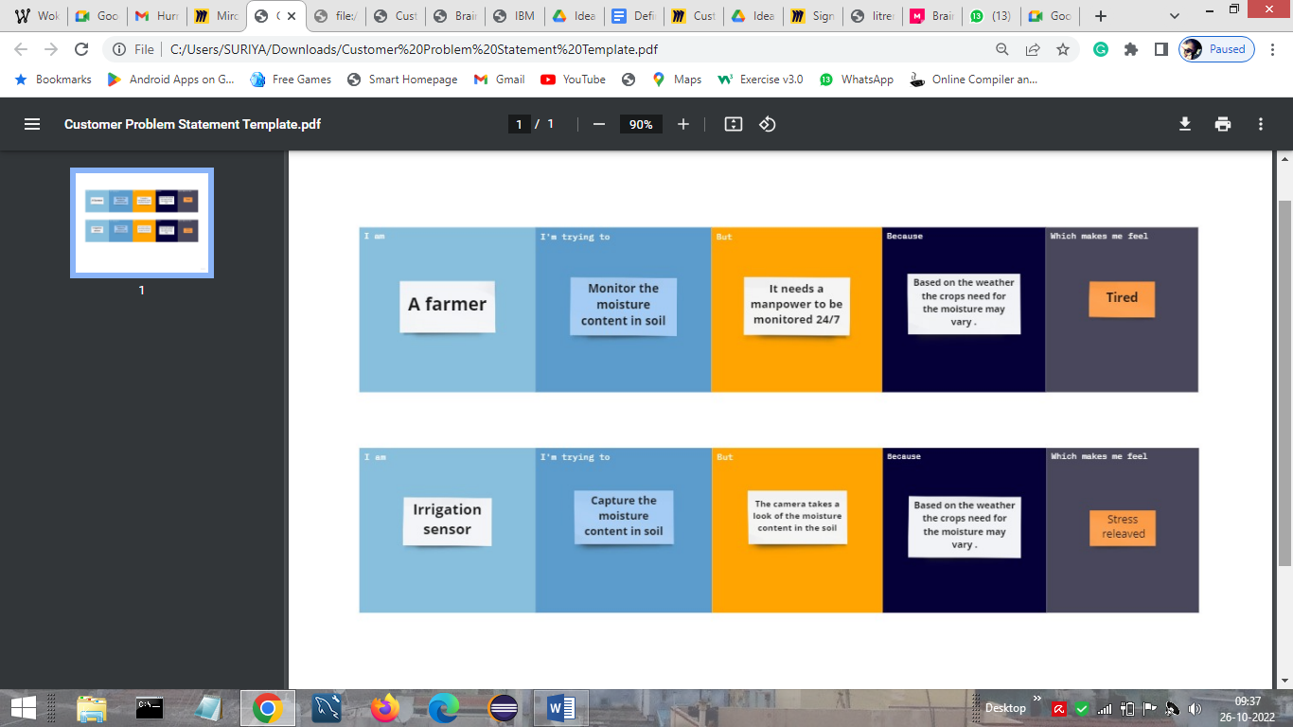

|  |  |  |  |  |  |
| --- | --- | --- | --- | --- | --- |
| **Problem Statement (PS)** | **I am (Customer)** | **I’m trying to** | **But** | **Because** | **Which makes me feel** |
| PS-1 | A farmer | Monitor the moisture content in soil | It needs a manpower to be monitored 24/7 | Based on the weather the crops need for the moisture may vary | Tired |
| PS-2 | Irrigation sensor | Capture the moisture content in the soil | The camera takes the look of the moisture content in the soil | Based on the weather the crops need for the moisture may vary | Stress relieved |